Angular Exercise

1. **Component and Routing – Create View Employee Component**  
  
Earlier employee details were created in the default app component itself.

* This now has to be moved to a new component named "view-emp". Follow the steps below:
* Create a new component in angular-learning application created earlier with component name "view-emp".
* Copy and paste relevant code from html and component source from app component to this new component.
* Create another component "edit-emp" to have a placeholder for another component that will be developed later. This is primarily to check how router navigation works.
* Include routing with router link “View Employee” and "Edit Employee" pointing to this new component. Clicking either one of the link should display the respective component. Refer sample layout below.

App.component.html:

<div class="container">

    <div class="row"></div>

    <div class="col-xs-12 col-sm-10 col-md-8 col-sm-offset-1 col-md-offset-2">

      <ul class="nav nav-tabs">

        <li role="presentation" routerLinkActive="active" [routerLinkActiveOptions]="{exact:true}"><a routerLink="/">View Employee</a></li>

        <li role="presentation" routerLinkActive="active"><a routerLink="/edit">Edit Employee</a></li>

      </ul>

    </div>

</div>

<div class="row">

    <div class="col-xs-12 col-sm-10 col-md-8 col-sm-offset-1 col-md-offset-2">

      <router-outlet></router-outlet>

    </div>

</div>

App-routing.component.ts:

import { NgModule } from '@angular/core';

import { Routes, RouterModule } from '@angular/router';

import { EditemployeeComponent } from './editemployee/editemployee.component';

import { EmployeeComponent } from './employee/employee.component';

import { PagenotfoundComponent } from './pagenotfound/pagenotfound.component';

const routes: Routes = [

  {path:'', component:EmployeeComponent},

  {path:'edit', component:EditemployeeComponent},

  {path:'not-found',component:PagenotfoundComponent},

  {path:'**',redirectTo:'/not-found'}

];

@NgModule({

  imports: [RouterModule.forRoot(routes)],

  exports: [RouterModule]

})

export class AppRoutingModule { }

Employee.component.html:

<div>

<h1> Employee details</h1>

<div class="well hoverwell thumbnail">

    <h2>Employee Id: {{emp.id}}</h2>

    <h2>Employee Name: {{emp.name}}</h2>

    <h2>Salary: {{emp.salary | currency:"INR"}}</h2>

    <h2 *ngIf="show">Permanent: Yes </h2>

    <h2>Department Id: {{emp.depart.department_id}}</h2>

    <h2>Department Name: {{emp.depart.department_name}}</h2>

    <h2>Skills</h2>

    <table >

        <tr>

            <th>Skill Id</th>

            <th>Skill Name</th>

     </tr>

     <tr *ngFor="let emp of empl">

        <td>{{emp.skill.skill_id}}</td>

        <td>{{emp.skill.skill_name}}</td>

    </tr>

        </table>

     <h2>Date Of Birth: {{emp.dateOfBirth | date:'longDate'}}</h2>

</div>

</div>

EditEmployee.component.html:

<p>Edit Employee works!</p>

OUTPUT: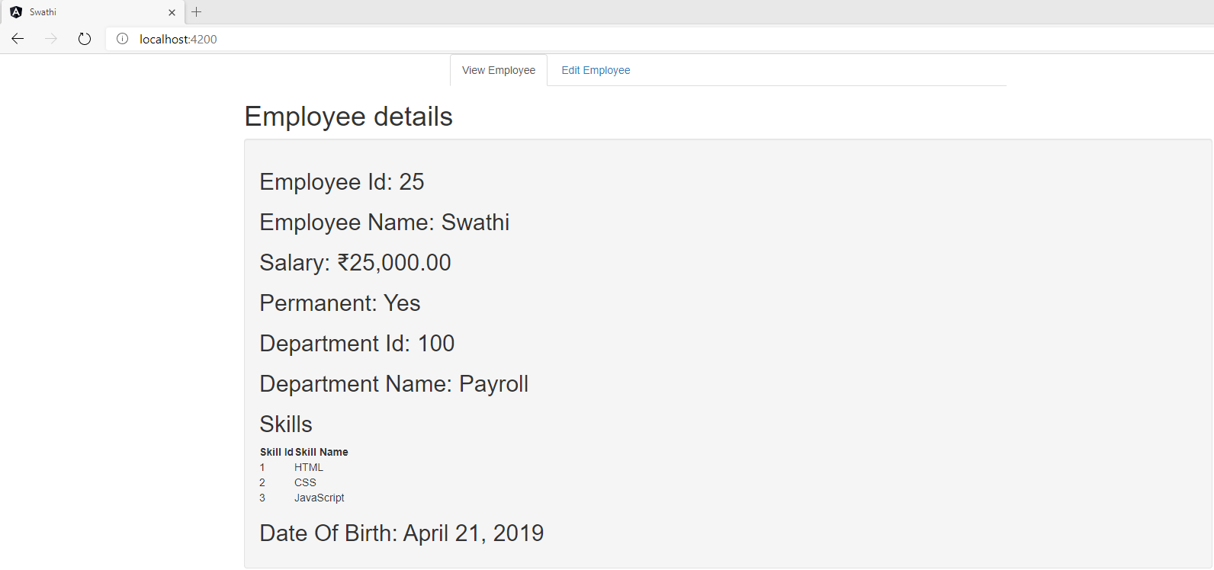

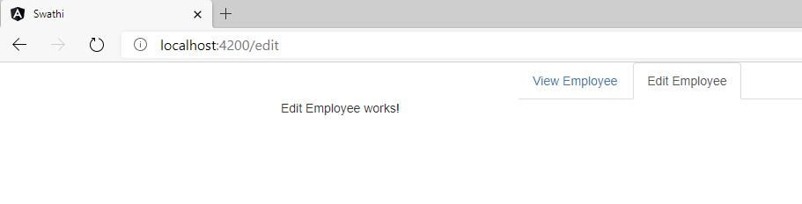

2.**Event Handling - Display value based on button click**  
  
In online food ordering apps, to add a specific food item with multiple quantity, there will be a plus and minus button that helps in increasing or decreasing the number of items. We are gradually going to build a component that will achieve this functionality.  
  
As part of this particular exercise we will create a button named "Click me". Clicking on this button should display the message "Click me button clicked!"  
  
Create a new component named "quantity-increment".

App.component.html:

<div class="container">

    <div class="row"></div>

    <div class="col-xs-12 col-sm-10 col-md-8 col-sm-offset-1 col-md-offset-2">

      <ul class="nav nav-tabs">

        <li role="presentation" routerLinkActive="active" [routerLinkActiveOptions]="{exact:true}"><a routerLink="/">View Employee</a></li>

        <li role="presentation" routerLinkActive="active"><a routerLink="/edit">Edit Employee</a></li>

        <li role="presentation" routerLinkActive="active"><a routerLink="/quantity">Quantity Increment</a></li>

      </ul>

    </div>

</div>

<div class="row">

    <div class="col-xs-12 col-sm-10 col-md-8 col-sm-offset-1 col-md-offset-2">

      <router-outlet></router-outlet>

    </div>

</div>

App-routing.module.ts;

import { NgModule } from '@angular/core';

import { Routes, RouterModule } from '@angular/router';

import { EditemployeeComponent } from './editemployee/editemployee.component';

import { EmployeeComponent } from './employee/employee.component';

import { PagenotfoundComponent } from './pagenotfound/pagenotfound.component';

import { QuantityIncrementComponent } from './quantity-increment/quantity-increment.component';

const routes: Routes = [

  {path:'', component:EmployeeComponent},

  {path:'edit', component:EditemployeeComponent},

  {path:'quantity', component:QuantityIncrementComponent},

  {path:'not-found',component:PagenotfoundComponent},

  {path:'**',redirectTo:'/not-found'}

];

@NgModule({

  imports: [RouterModule.forRoot(routes)],

  exports: [RouterModule]

})

export class AppRoutingModule { }

Quantity-increment.component.ts:

import { Component, OnInit } from '@angular/core';

@Component({

  selector: 'app-quantity-increment',

  template: `

  <button (click)="onClickMe()">Click me!</button>

  {{clickMessage}}`

})

export class QuantityIncrementComponent implements OnInit {

  constructor() { }

  ngOnInit(): void {

  }

  clickMessage = '';

  onClickMe() {

    this.clickMessage = 'Click Me Button Clicked!';

  }

}

Layout before button click:

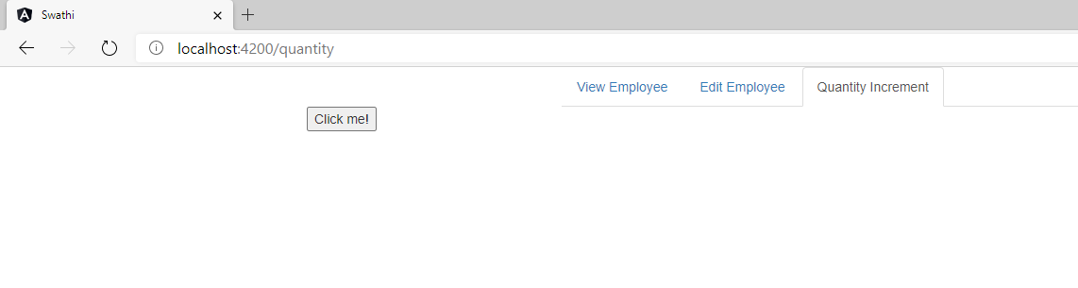

Layout after button click:

